**Dynamic Routing-RIP (Routing Information Protocol)**

**Introduction**: In the static routing we had to figure the routing for all the routers involved individually. Which was time consuming and also for a bigger network, it would be close to impossible to configure each and every router for establishing connection between each other. But with the help of dynamic routing we can solve that problem. There are many types of dynamic routing protocol which we can follow but for now, I’ll be using the RIP, which is the short form of Routing Information Protocol. With RIP, all we have to do is configure only one router and all the other routers will be connected to it automatically. I won’t have to connect to each and every router individually anymore.

**Set-up:** First, I will be taking all the devices and create a structure. I am taking total 6 routers, there are two switches with each router so I have taken 12 switches. Each switch is connected to a single PC and a single Server, so, in Total I had to take 12 PCs and 12 Servers. Then I connected the wires and interconnected all devices. After that it looks like this:

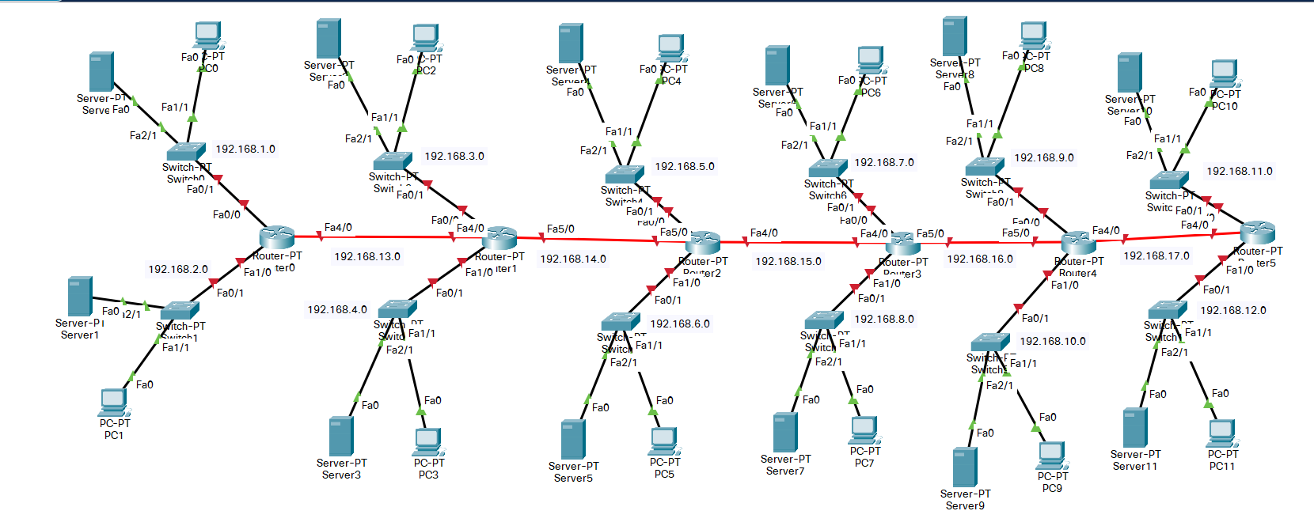

As you can see, have also divided network addresses here. I have total 17 network addresses which are from ‘192.168.1.0’ to ‘192.168.17.0’. I will explain these addresses later on.

**IP Configuration of the Routers:**

Router0: F0/0: IP: 192.168.1.1, Subnet Mask: 255.255.255.0

F1/0: IP: 192.168.2.1, Subnet Mask: 255.255.255.0

F4/0: IP: 192.168.13.1, Subnet Mask: 255.255.255.0

Router1: F0/0: IP: 192.168.3.1, Subnet Mask: 255.255.255.0

F1/0: IP: 192.168.4.1, Subnet Mask: 255.255.255.0

F4/0: IP: 192.168.13.2, Subnet Mask: 255.255.255.0

F5/0: IP: 192.168.14.1, Subnet Mask: 255.255.255.0

Router2: F0/0: IP: 192.168.5.1, Subnet Mask: 255.255.255.0

F1/0: IP: 192.168.6.1, Subnet Mask: 255.255.255.0

F4/0: IP: 192.168.15.1, Subnet Mask: 255.255.255.0

F5/0: IP: 192.168.14.2, Subnet Mask: 255.255.255.0

Router3: F0/0: IP: 192.168.7.1, Subnet Mask: 255.255.255.0

F1/0: IP: 192.168.8.1, Subnet Mask: 255.255.255.0

F4/0: IP: 192.168.15.2, Subnet Mask: 255.255.255.0

F5/0: IP: 192.168.16.1, Subnet Mask: 255.255.255.0

Router4: F0/0: IP: 192.168.9.1, Subnet Mask: 255.255.255.0

F1/0: IP: 192.168.10.1, Subnet Mask: 255.255.255.0

F4/0: IP: 192.168.17.1, Subnet Mask: 255.255.255.0

F5/0: IP: 192.168.16.2, Subnet Mask: 255.255.255.0

Router5: F0/0: IP: 192.168.11.1, Subnet Mask: 255.255.255.0

F1/0: IP: 192.168.12.1, Subnet Mask: 255.255.255.0

F4/0: IP: 192.168.17.2, Subnet Mask: 255.255.255.0

**RIP Configuration:** This is how I am adding all the network addresses in the RIP:

Router0: Network Addresses: 192.168.1.0

192.168.2.0

192.168.13.0

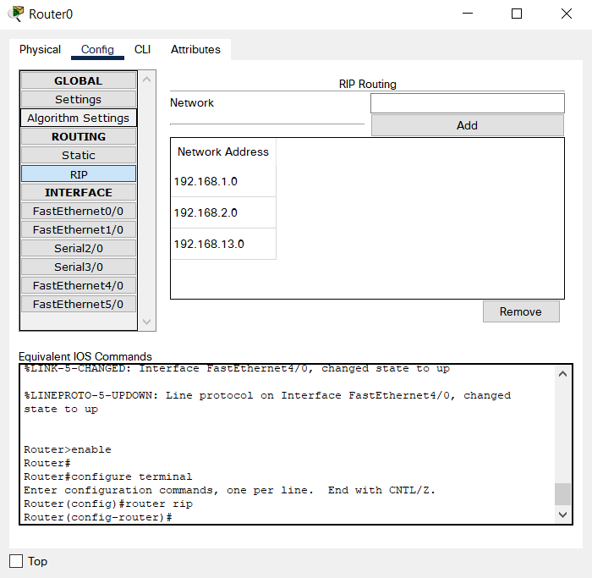

Router1: Network Addresses: 192.168.3.0

192.168.4.0

192.168.13.0

192.168.14.0

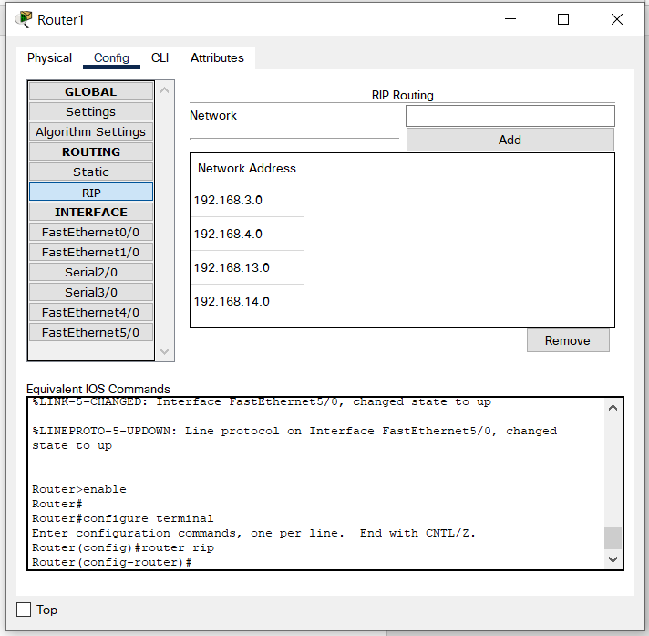

Router2: Network Addresses: 192.168.5.0

192.168.6.0

192.168.14.0

192.168.15.0

Router3: Network Addresses: 192.168.7.0

192.168.8.0

192.168.15.0

192.168.16.0

Router4: Network Addresses: 192.168.9.0

192.168.10.0

192.168.16.0

192.168.17.0

Router5: Network Addresses: 192.168.11.0

192.168.12.0

192.168.17.0

Now after adding all the addresses through RIP, if I check I can see that, I can access to all the netoworks with Router0 which I didn’t even add manually. To see that I had to use a command, “show ip route” and this is the result I got, the screenshot of the result is attatched:

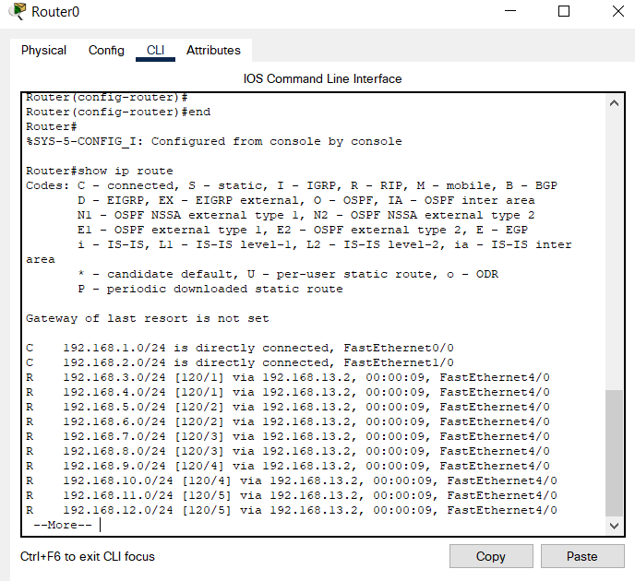

Now, I can ping any network from any network. After that, I am going to configure 12 servers and 12 PCs.

**Server Configuration:** For configuring servers I have to assign each router to it’s own ip address. Here is the full IP configuration for each servers:

Server0: IP Address: 192.168.1.254,

Subnet Mask: 255.255.255.0,

Default Gateway: 192.168.1.1,

DNS Server: 192.168.1.254

Server1: IP Address: 192.168.2.254,

Subnet Mask: 255.255.255.0,

Default Gateway: 192.168.2.1,

DNS Server: 192.168.1.254

Server2: IP Address: 192.168.3.254,

Subnet Mask: 255.255.255.0,

Default Gateway: 192.168.3.1,

DNS Server: 192.168.1.254

Server3: IP Address: 192.168.4.254,

Subnet Mask: 255.255.255.0,

Default Gateway: 192.168.4.1,

DNS Server: 192.168.1.254

Server4: IP Address: 192.168.5.254,

Subnet Mask: 255.255.255.0,

Default Gateway: 192.168.5.1,

DNS Server: 192.168.1.254

Server5: IP Address: 192.168.6.254,

Subnet Mask: 255.255.255.0,

Default Gateway: 192.168.6.1,

DNS Server: 192.168.1.254

Server6: IP Address: 192.168.7.254,

Subnet Mask: 255.255.255.0,

Default Gateway: 192.168.7.1,

DNS Server: 192.168.1.254

Server7: IP Address: 192.168.8.254,

Subnet Mask: 255.255.255.0,

Default Gateway: 192.168.8.1,

DNS Server: 192.168.1.254

Server8: IP Address: 192.168.9.254,

Subnet Mask: 255.255.255.0,

Default Gateway: 192.168.9.1,

DNS Server: 192.168.1.254

Server9: IP Address: 192.168.10.254,

Subnet Mask: 255.255.255.0,

Default Gateway: 192.168.10.1,

DNS Server: 192.168.1.254

Server10: IP Address: 192.168.11.254,

Subnet Mask: 255.255.255.0,

Default Gateway: 192.168.11.1,

DNS Server: 192.168.1.254

Server11: IP Address: 192.168.12.254,

Subnet Mask: 255.255.255.0,

Default Gateway: 192.168.12.1,

DNS Server: 192.168.1.254

Heres’s a screenshot of one of the servers given as example:

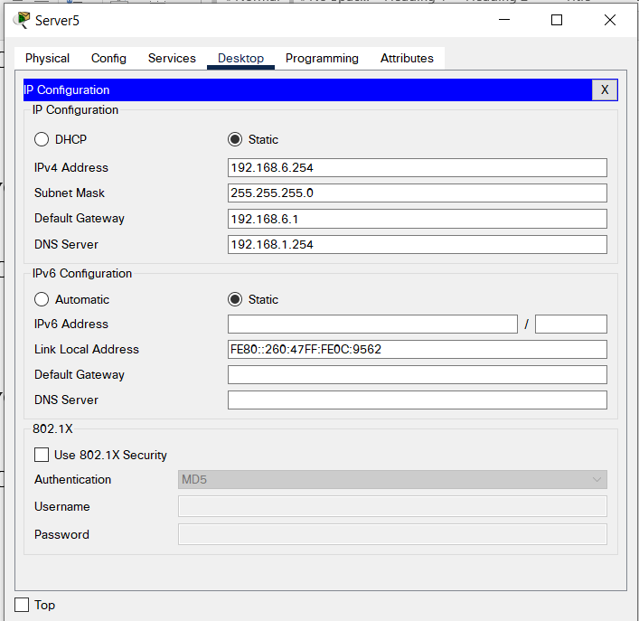

Here, only Server0 is the DNS server. And I have made 6 web servers as well. Which are Server0, Server1, Server2, Server3, Server4 and Server5. The names of each web server is given with their IP address below:

www.google.com --> 192.168.1.254

www.facebook.com --> 192.168.2.254

www.uap.edu --> 192.168.3.254

www.cse.edu --> 192.168.4.254

www.eee.edu --> 192.168.5.254

www.civil.edu --> 192.168.6.254

Here is a screenshot of how I added all these servers in my DNS server which is Server0 in this case:

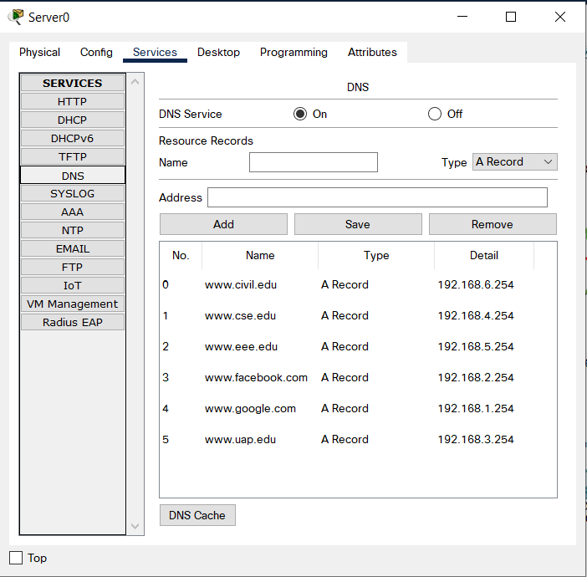

After that, I had to figure out the DHCP service in all my servers. Which later on helped me assigning a randomized IP address to all the PCs.

Here’s a screenshot of how I switched on the DCHP server on all the servers from Server0 to Server11:

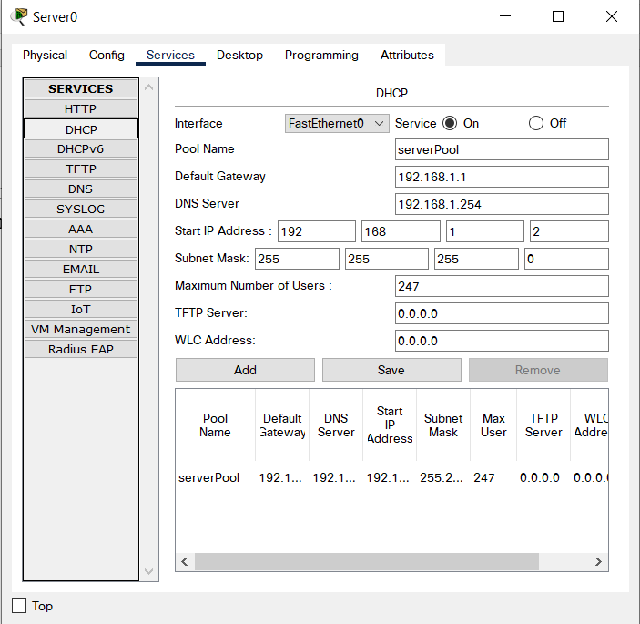

After this, all I had to do is access to the IP configuration of each PCs and tick in the DHCP option, and this is how each PC got assigned it’s IP Addresses:

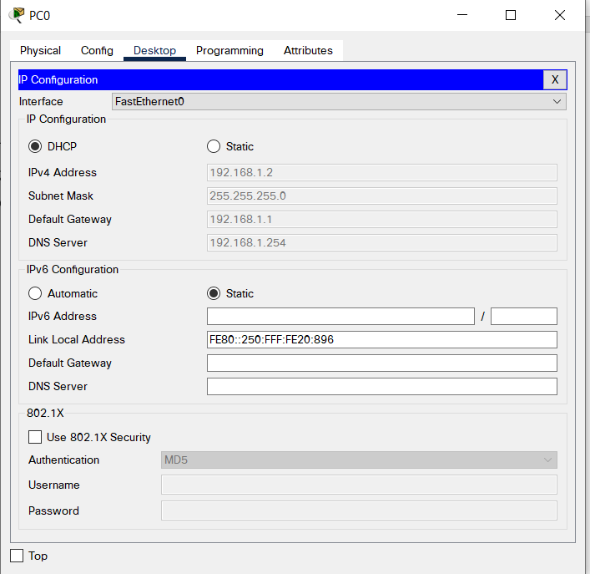

Now, my full connection is complete. Let’s ping into different networks now to see if it works right or not. Here’s the screenshot of me pinging into various networks:

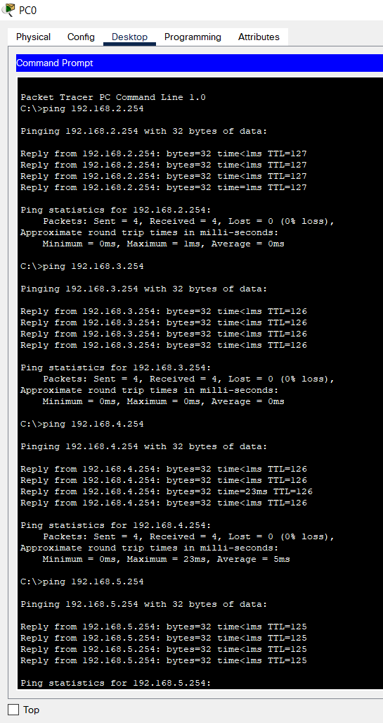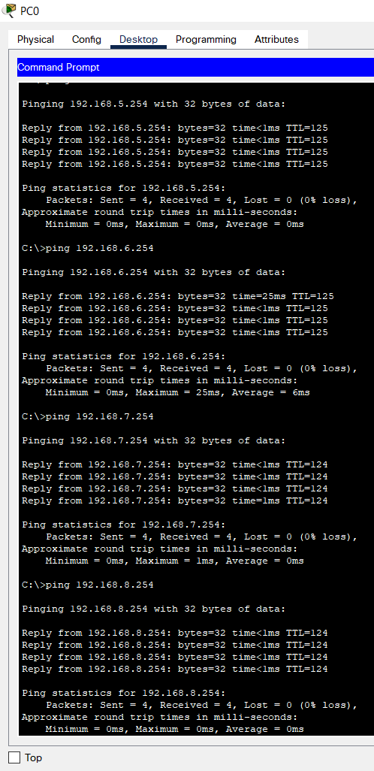

So, as I can see my network is working perfectly and it’s connecting with each and every IP adresses perfectly. Now, let’s visit my web servers and see if they work perfectly.

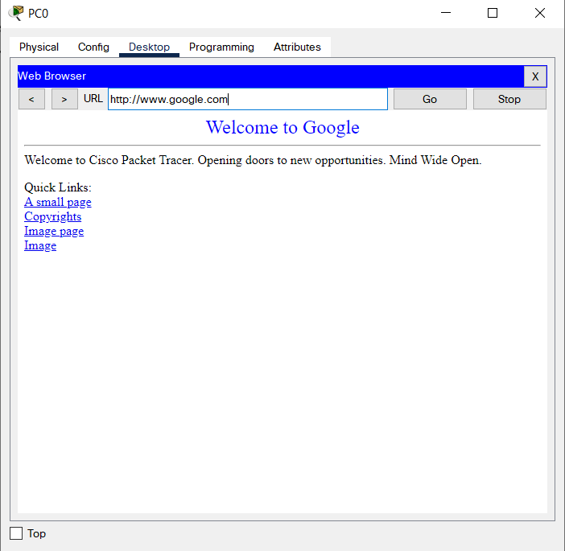

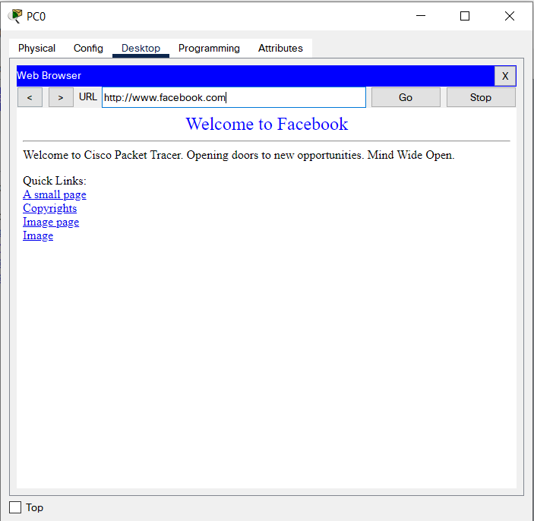

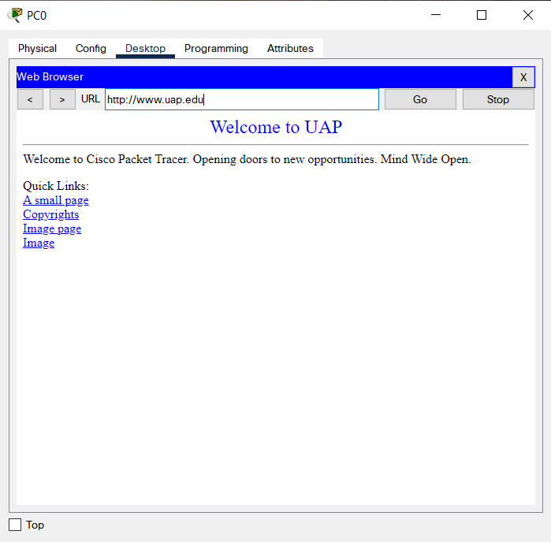

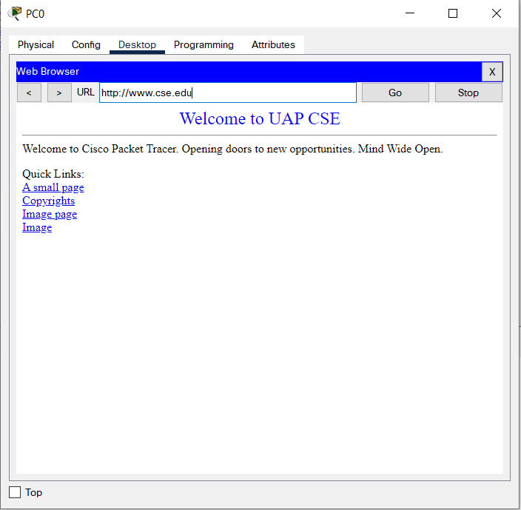

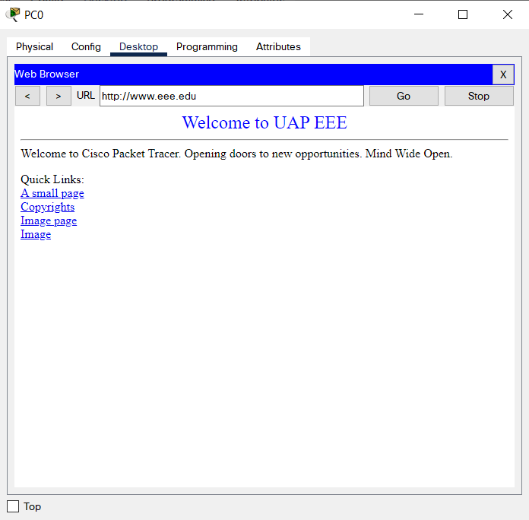

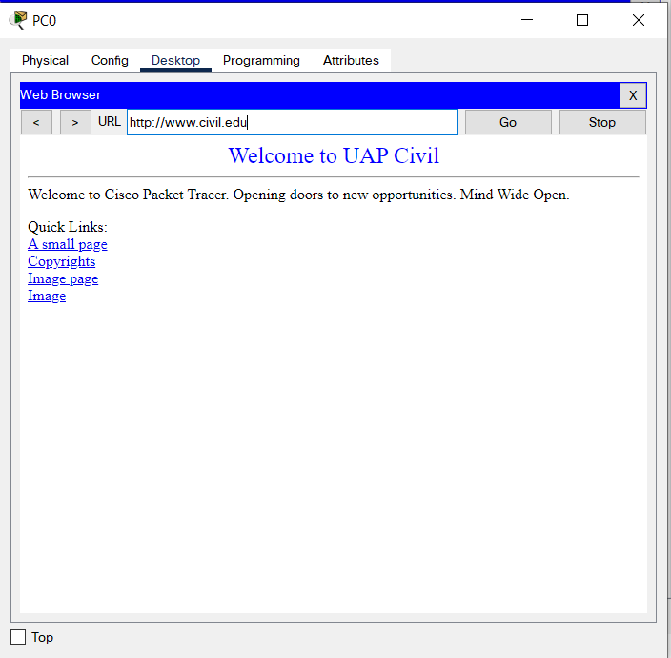

So, here we can see, my network works perfectly and each web servers are being accessed successfully. So, this is it, that’s how I have used RIP to connect and design this whole network. I am attatching my Cisco Packet tracer file as well so that you can check if needed.

--0--